ve

* **Central Equipment Identity Register Portal**

**Custom User Manual v 2.0**

Document Change History

|  |  |  |  |
| --- | --- | --- | --- |
| Version | Change Type | Description | Date |
| Draft |  | Submitted for internal review | February 2020 |

Contents

Document Change History i

Contents ii

Figures iii

1 Overview 1

1.1 Scope 1

1.2 Acronyms & Abbreviations 1

1.3 Conventions 1

2 Custom Operations 2

2.1 Application Overview 2

2.2 Logging into the Application 3

2.3 Application User Interface 10

2.3.1 Dashboard 12

2.4 Consignments 18

2.5 Approve Consignments 23

2.6 Filter Consignments 24

2.7 Sorting Consignments 25

2.8 Export Consignments 25

2.9 Stock Management 26

2.10 Edit Stock 30

2.11 Filter Stock 31

2.12 Sorting Stock 32

2.13 Export Stock 32

2.14 Grievance Management 34

2.15 Filter Grievances 37

2.16 Sorting Grievance 38

2.17 Export Grievances 39

2.18 Registering Devices 40

2.18.1 Registering Imported Devices 40

2.19 Filtering Register Device Requests 47

2.20 Sorting Register Device Requests 47

2.21 Exporting Register Device Requests 48

Figures

Figure 1: CEIR Home Page 3

Figure 2: Custom Registration 4

Figure 3: Verify OTP 6

Figure 4: Enter OTP 6

Figure 5: Login 7

Figure 6: Home Page 8

Figure 7: Forgot Password 9

Figure 8: Set New Password 9

Figure 9: Home Page 10

Figure 10: Edit Information 11

Figure 11: Change Password 11

Figure 12: Manage Account 12

Figure 13: Home Page 13

Figure 14: Consignment 13

Figure 15: Stock Management 14

Figure 16: Grievance Management 15

Figure 17: Register Device 16

Figure 18: Register Device 17

Figure 19: Home Page 17

Figure 20: Consignment Page 19

Figure 21: View Consignment Page 22

Figure 23: Consignment 23

Figure 24: Consignment 24

Figure 25: Filtered Consignment 25

Figure 26: Sort Consignment 25

Figure 27: Consignment 25

Figure 27: Open or Save Exported Consignment File 26

Figure 28: Exported Consignments 26

Figure 29: Stock Management Page 27

Figure 30: Assign Stock 27

Figure 31: Stock Management 28

Figure 32: Stock Management 31

Figure 33: Edit Stock 31

Figure 34: Stock Management 31

Figure 35: Stock Management 32

Figure 39: Stock Management 32

Figure 36: Stock Management 33

Figure 37: Open or Save Exported Stock File 33

Figure 38: Exported Stock 33

Figure 39: Grievance Page 34

Figure 40: Create Grievance 35

Figure 41: Grievance Management 36

Figure 42: Filter Grievances 37

Figure 43: Filtered Grievances 38

Figure 39: Grievance Management 38

Figure 44: Grievance Management 39

Figure 45: Open or Save Exported Grievance File 39

Figure 46: Exported Grievances 39

Figure 47: Register Device 40

Figure 48: Register Device 40

Figure 50: Register Device 42

Figure 51: Register Device 42

Figure 52: Register Device 44

Figure 53: Filter Device Requests 47

Figure 54: Register Device 48

Figure 55: Open or Save Register Device File 49

Figure 56: Exported Register Device File 49

# Overview

## Scope

The objective of this manual is to help customs user use the CEIR (Central Equipment Identity Register) application to clear consignments, raise confiscated stock requests, collect tax for register devices and report grievances.

## Acronyms & Abbreviations

| **Acronym** | **Full Form** |
| --- | --- |
| CEIR | Central Equipment Identity Register |
| IMEI | International Mobile Equipment Identity |
| PDA | Personal Digital Assistant |
| TAC | Type Allocation Code |
| TRC | Telecommunication Regulator of Cambodia |

## Conventions

| **Information** | **Convention** |
| --- | --- |
| UI elements  (such as names of windows, buttons, and fields) | Bold |
| References  (such as names of files, sections, paths, and  parameters) | *Italics* |
| **\*** | Indicates a mandatory field or column |

# Custom Operations

## Application Overview

The CEIR (Central Equipment Identity Register) Custom Portal application is used to collect tax for SIM-based devices that are imported in Cambodia. Registration of all the imported devices ensures proper tax is paid to the customs before the devices are made available for sale in the market. In addition, registration helps in tracking device movement and prevents their misuse or theft.

After purchasing devices from suppliers, the importers register necessary information about the devices and suppliers in the system. The registered information is reviewed and approved by the CEIR Admin and subsequently shared with the customs for clearance. When the physical consignment of the devices is received at the customs premises, the importers go and pay the required tax and collect the consignment. After the taxes are paid, the consignment is made available to distributors and retailers for sale in the market.

Customs perform the following tasks:

* Clear imported device consignments
* Upload stock (if the devices is not collected by importer within the stipulated time)
* Register devices and collect tax from end user.
* Report grievances

## Logging into the Application

Before login, the custom must register in the application.

To register:

1. Enter the CEIR Home Portal URL in the browser address bar. This opens the CEIR Home Portal page.

Figure 1: CEIR Home Page

1. Select **Custom** from the **Registration** list.

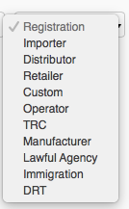

The **Custom Registration** page appears. The importer needs to fill in the following information.

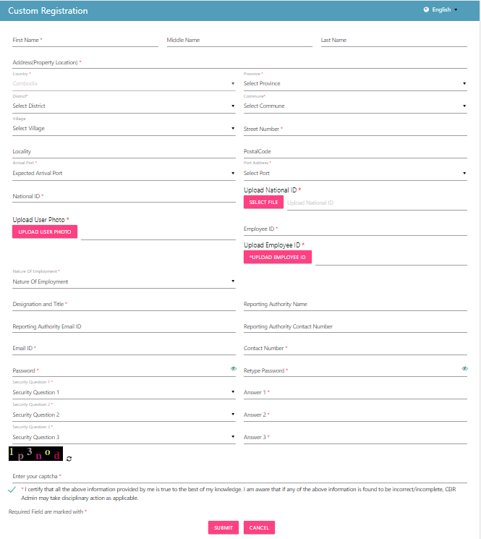

Figure 2: Custom Registration

1. **\*First Name**: Enter the first name.
2. **Middle Name**: Enter the middle name (if any).
3. **\*Last Name**: Enter the last name.
4. **\*Address**: Enter the custom’s address:
   1. **\***Street Number
   2. Village
   3. Locality
   4. **\***District
   5. **\***Commune
   6. **\***Province
   7. **\***Country
5. **\*Arrival Port**: Select the arrival port from the list (Land, Water, Air).
6. **\*Port Address:** Select the port address from the list
7. **\*National ID:** Enter the national ID of the agency personnel.
8. **\*Upload National ID**: Upload the image of the original national ID of the personnel. This can be a pdf or image (.jpeg) of size not more than 2 MB.
9. **\*Upload Photo**: Upload the photograph of the personnel. The photograph can be a pdf or image (.jpeg) of size not more than 2 MB.
10. **\*Employee ID**: Enter the employee ID.
11. **\*Upload Employee ID Card**: Upload the image of the Employee ID card. The photograph can be a pdf or image (.jpeg) of size not more than 2 MB.
12. **\*Nature of Employment**: Select the type of employment of the personnel:
    1. Permanent
    2. Temporary
    3. Contract
13. **\*Designation and Title**: Enter the designation of the agency personnel.
14. **Reporting Authority Name**: Enter the name of the officer to whom the personnel reports to.
15. **Reporting Authority Email ID**: Enter the mail ID of the officer to whom the personnel reports to.
16. **Reporting Authority Contact Number**: Enter the contact number of the officer to whom the personnel reports to.
17. **\*Email**: Enter the mail ID of the personnel. This mail ID would be used for communication
18. **\*Contact Number**: Enter the mobile number of the personnel. The agency would receive notifications at this mobile number.
19. **\*Password**: Enter a login password. This is the password that would be used to log into the CEIR Importer Portal application.
20. **\*Confirm Password**: Re-enter the password for confirmation.
21. **\***Select three security questions and enter an answer for each question. This is required by the system when the importer forgets the password. In such a situation, the system requires identification to authenticate the importer. These security questions are used for authentication of the importer.
22. **\***Enter the captcha shown on the page. This is required to prove that the importer is not a robot.
23. **\***Select the declaration check box.
24. Click **SUBMIT**.

An OTP is sent to the custom’s mail ID and contact number.

Figure 3: Verify OTP

The custom is prompted to enter both the OTPs in the page for verification.

Figure 4: Enter OTP

Enter the two OTPs and click **Done**.

If the two OTPs match, the following message appears. If the OTPs do not match, click **Resend OTP**. The two OTPs are resent, one to the contact number and the other to the mail account.

After the OTPs are verified successfully, the registration request is sent to the CEIR Admin. The approval turnaround time is 2-3 days. After approval from the CEIR Admin, a mail containing the custom’s registration ID is sent to the custom’s mail account. This registration ID is a unique automatically generated ID. This ID is the login username for access to the CEIR Custom Portal application.

To start using the application, log into the application.

To login:

1. Open the browser and enter the CEIR Custom Portal URL in the address bar. The login screen appears.

Figure 5: Login

On the top right corner of the login screen is the **Language** option. The application supports two languages: **English** and **Khmer**. On selecting a given language, all the field and column labels in the application appear in the selected language. All user inputs are, however, in English.

1. Next, enter the assigned login username and password.

Username is the registration ID that is sent on mail to the custom after successful registration in the system. The registration ID is a unique ID that is automatically generated by the system. The login password is the password that the custom enters in the registration page. Refer to during *Figure 2: Custom Registration*.

1. Enter the captcha.
2. Click **LOGIN**.

If the login and password are incorrect or the captcha is not correct, an error message appears, and you are prompted to re-enter the login details.

On entering correct information, the application home page appears.

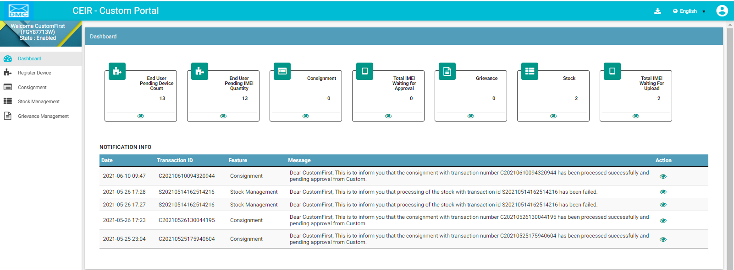

Figure 6: Home Page

If the custom forgets the assigned password, click the **Forgot Password** link on the **Login** page. The **Forgot Password** page appears.

Figure 7: Forgot Password

1. Enter the login username.
2. Select a security question from the list. Select any one of the security questions that were selected during registration.
3. Enter the answer to the selected security question. This should match the answer given at the time of registration.
4. Click **SUBMIT**.

The **Set New Password** page appears.

Figure 8: Set New Password

1. Enter a new password. Click  to see the password characters being entered. Click on it again to hide the password characters. This works like a toggle key.
2. Re-enter the password.
3. Click **Save**.

## Application User Interface

On logging into the application successfully, the CEIR Custom Portal Home page appears.



Figure 9: Home Page

The Home page has all the feature menus on the left panel.

The center of the page is the Dashboard.

The top right corner of the screen displays the following menu options:

* **Download**: Click to download this user manual.
* **English**: Select **English** or **Khmer**. All the field and column labels appear in the selected language. User inputs are, however, in English.

* A close up of a logo

  Description automatically generated(**User profile**): Click on it to see the following menu:

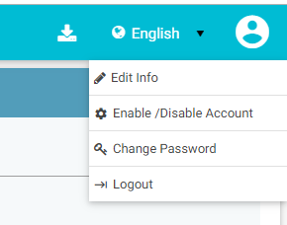

*  (**Edit Info**): Click on it to modify the registered information. The **Edit Information** page opens.

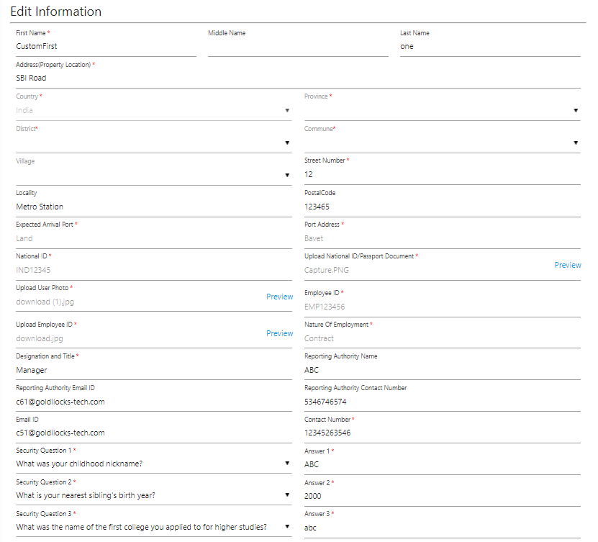

Figure 10: Edit Information

1. Make the required changes.
2. Click **Submit** to save the changes.

*  (**Change Password**): Click on it change the login password.

Figure 11: Change Password

1. **Old Password**: Enter the existing password. Click  to see the password characters being entered. Click on it again to hide the password characters. This works like a toggle key.
2. **New Password**: Enter a new password.
3. **Confirm Password**: Re-enter the new password to confirm the password.
4. Click **SUBMIT**.

*  (**Enable/Disable Account**): Customs can deactivate their account or disable/enable their account.
  + Deactivating an account means deleting the custom’s account. Once the custom’s account is deleted, the custom can raise a grievance to reactivate it when required. The grievance is sent to the CEIR Admin who reactivates the account. After reactivation, the custom can use the same login username and password to log into the application.
  + When the account is disabled, customs can only view information and not add or modify information in the application. After the account is disabled, the custom can enable it using the same menu.

Figure 12: Manage Account

1. Select **Deactivate** or **Disable**.
2. Click **SUBMIT**.

### Dashboard

The Dashboard provides a quick display and access to the following information:

* Consignments
* Stock
* Register Devices
* Grievances



Figure 13: Home Page

**Consignments**

The **Consignment** box displays the total number of consignments waiting to be cleared by the customs.

Click  (**View**) to go to the **Consignment** dashboard. Refer to *Consignment Management* for more information.

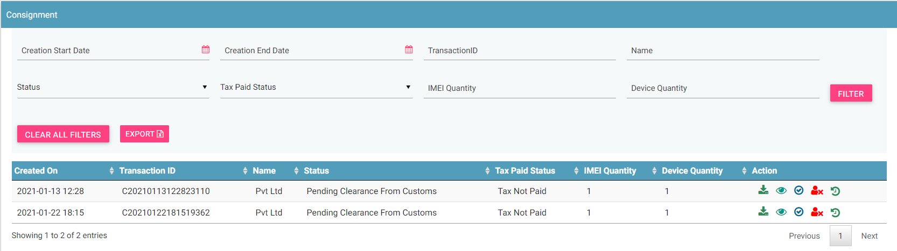

Figure 14: Consignment

**Total IMEI waiting for approval**

This box displays the total number of devices (IMEIs in the consignments) waiting to be cleared by the customs.

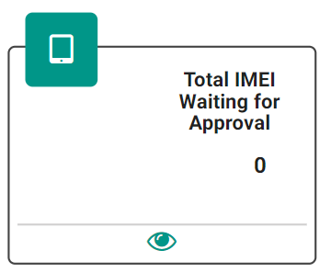

Click  (**View)** to access the **Consignment** dashboard. Refer to *Consignment Management* for more information.

**Stock**

The stock box displays the total number stock entries pending approval.

Click  (**View)** to access the **Stock Management** dashboard. Refer to *Stock Management* for more information.

Figure 15: Stock Management

**Total Devices Waiting for Upload**

The box displays the total number of devices (IMEIs in stock) pending for upload.

Click  (**View)** to access the **Stock Management** dashboard. Refer to *Stock Management* for more information.

**Grievances**

The box displays the total number of grievances that are open.

Click  **(View)** to access the **Grievance Management** dashboard. Refer to *Grievance Management* for more information.

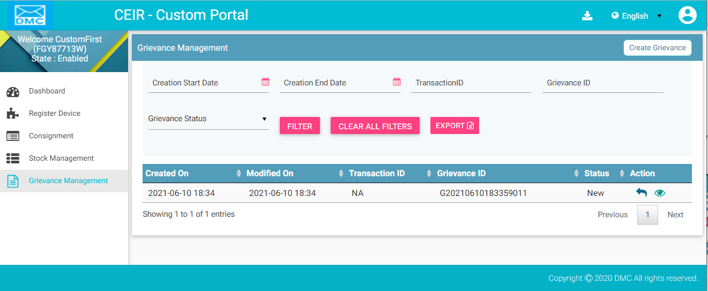

Figure 16: Grievance Management

**End User Pending Device Count**

The box displays the total number of end user device requests that are pending for approval.

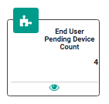  
Click  (**View**) to access the **Register Device** dashboard. Refer to *Register Device* for more information.

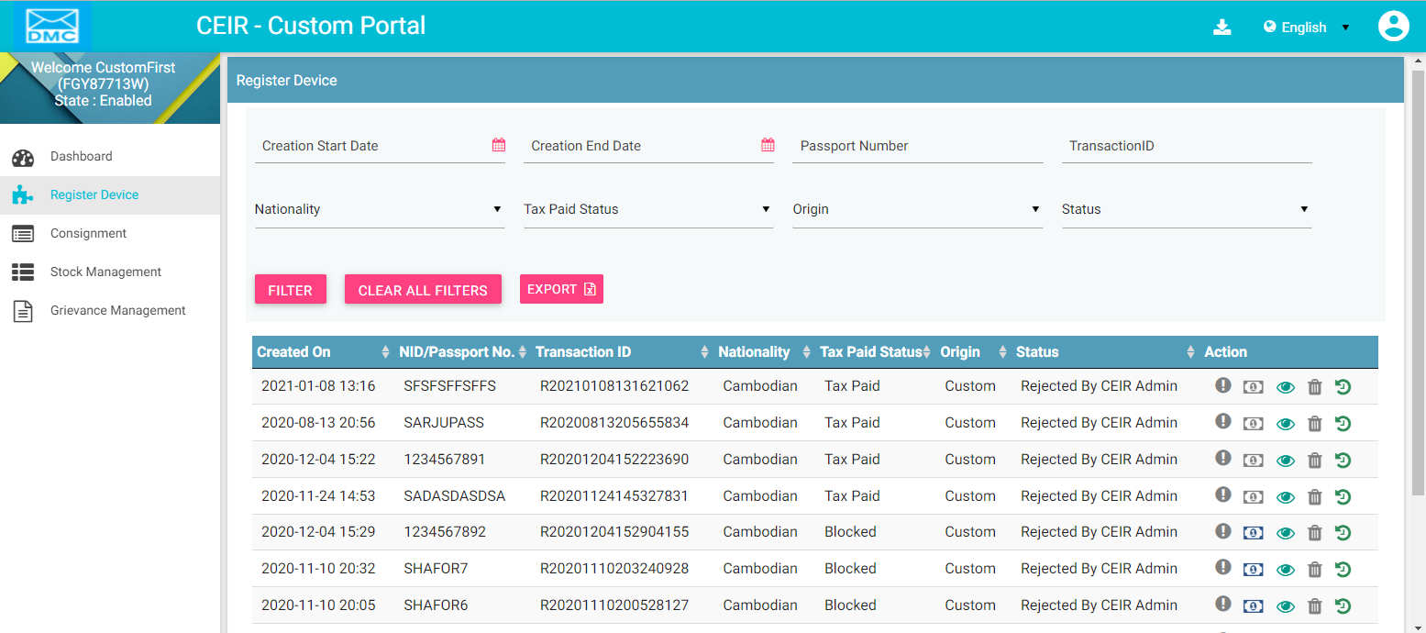

Figure 17: Register Device

**End User Pending IMEI Count**

The box displays the total number of end user device IMEI that are pending for approval.

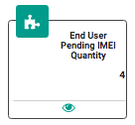

Click  (**View**) to access the **Register Device** dashboard. Refer to *Register Device* for more information.



Figure 18: Register Device

**Notification Information**

This section displays the most recent notifications. System Admin can configure the number of notifications that are displayed on user dashboard.

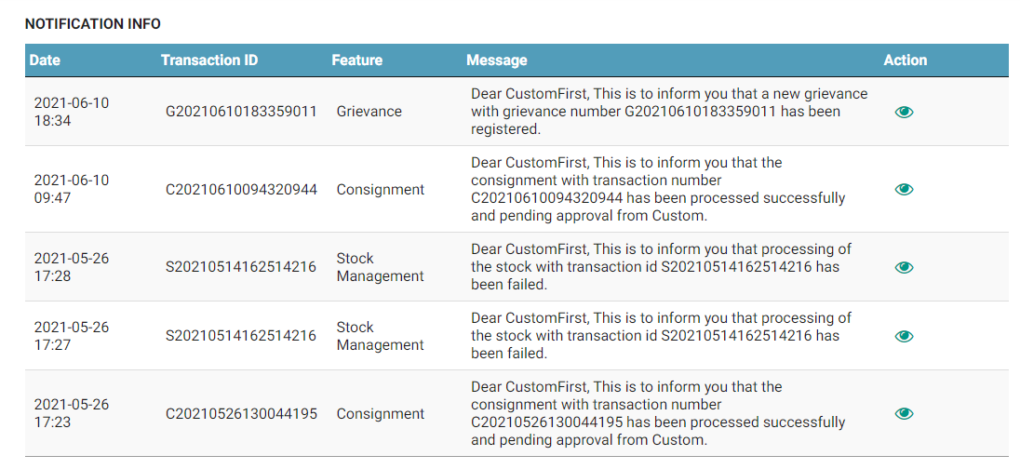

Figure 19: Home Page

Notifications are of two types.

1. Notifications that provide only information. For example, a notification informing the custom about the account status is an information only notification because it requires no action. The **View** icon () is disabled in such notifications.



1. Notifications that require some action by the custom. For example, a notification about the consignment approval by the CEIR Admin and need clearance from customs The **View** icon () is enabled in such notifications. Click  (**View)** to access the relevant page of the notification.



The notification panel has the following columns:

* **Date**: Date of sending the notification
* **Transaction ID**: Transaction ID of the consignment or stock or grievance or register device request for which the notification is sent. If the notification is related to the custom account, the login username is shown instead of any transaction ID.
* **Feature**: This is the name of the feature for which the notification is sent. For example, if the notification is for a consignment, the feature name **Consignment** is shown. If the notification is concerning a stock transaction, the feature name **Stock Management** is shown. The feature name is the one shown in the left panel of the Home page.
* **Message**: This is the message of the notification. An example is shown below.



* **Action**: This shows the **View** icon. It is activated  if the custom can click on it else it is disabled .

## Consignments

Importers purchase consignments from suppliers. After a consignment is ordered, the importer must register the imported consignment in the application.

The flow of information in the consignment lifecycle is as follows:

1. After ordering a consignment from a supplier, the importer registers the consignment and supplier information in the system.
2. The system validates the information.
3. If the system rejects it, the information is available to importers for correction and the above flow is repeated.
4. On successful validation, the CEIR Admin reviews the information for completeness and accuracy.
5. If the CEIR Admin rejects it, the information is available to importers for correction and the above flow is repeated.
6. After it is approved by the CEIR Admin, it is shared with the customs for clearance.
7. If the customs reject the consignment, the information is available to importers for correction and the above flow is repeated.
8. After the physical consignment arrives at the customs premises, the importer goes to the customs office and pays the required tax. Customs clear the consignment and hands it over to the importer. The consignment is now ready for sale in the market.

Note: In case the importer raises a consignment, with TAC information which is not approved with TAC authority using Manage Type approval Feature, the custom officer will approve the consignment only after validating a valid TAC certificate for the same.

To clear consignments in the application:

1. Select the **Consignment** menu in the left panel of the application Home page.  
   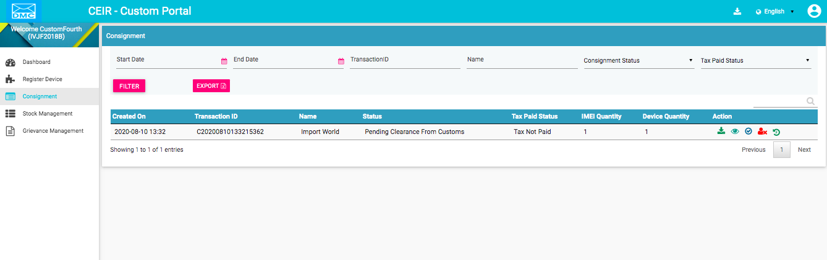

Figure 20: Consignment Page

For each consignment uploaded, the dashboard displays the following information:

| **Column** | **Description** |
| --- | --- |
| Creation Date | Date of registering the consignment in the system. |
| Transaction ID | This is an automatically generated ID that is assigned to the consignment when it is registered. |
| Importer Name | Name of the improter. |
| Consignment Status | The registered consignment goes through different status modes.   * Pending Clearance from Customs: After the consignment is approved by the CEIR Admin, the consignment is available for clearance by the customs. * Approved: When the customs clear the consignment, the status changes to **Approved**. * Rejected by Customs: When the customs do not clear the consignment, the status changes to **Rejected**. The importer can view the file and fix the errors in the consignment. |
| Tax Paid Status | Indicates whether tax has been paid or not. The status changes to **Tax Paid** when the customs clear the consignment. |
| IMEI Quantity | This is the number of IMEIs in the consignment. |
| Device Quantity | This is the number of devices in the consignment. |
| Action | This displays different actions that can be performed on the consignment.   * Download A circuit board    Description automatically generated: This is used to take a dump of the consignment file that is uploaded to the system * View : This is used to view the request details. * Approve : This is used to approve the request. * Reject : This is used to reject the request. * History : This is used to view the history of this request. |

On view of the consignment details, following information is displayed

1. Enter the following information:
   1. **Supplier/Manufacturer ID**: The supplier or manufacturer ID from whom the importer has purchased the consignment.
   2. **Supplier/Manufacturer Name**: The supplier’s name.
   3. **Consignment Number**: The consignment number.
   4. **Expected Dispatch Date**: The date by when the consignment would be dispatched by the supplier.
   5. **Device Origination Country**: The country from where the consignment is being sent.
   6. **Expected Arrival Date**: The date by when the consignment would reach the customs premises.
   7. **IMEI Quantity**: The number of IMEIs in the consignment.
   8. **Device Quantity**: The number of unique devices in the consignment.
   9. **Total Price**: The total price of the consignment.
   10. **Currency**: The currency
   11. **Expected Arrival Port**: Denotes if the consignment is being sent by air, land, or sea.
   12. **Port Address**: Address of the port where consignment is being sent.
   13. **Upload Bulk Devices Information**: Enter the consignment details in a file. This is a **.csv** file with defined column names. You need to enter device information under each column.

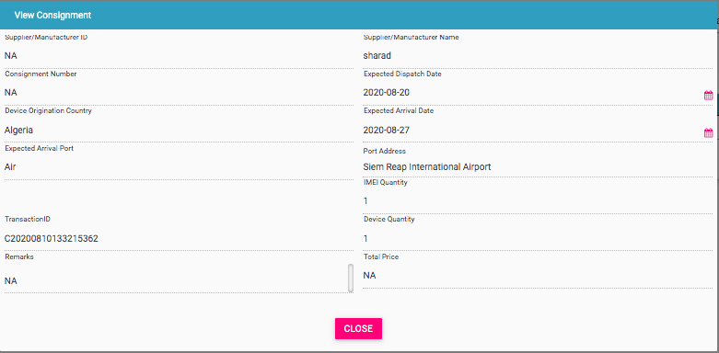

Figure 21: View Consignment Page

To view the content of the file, click on the download icon. The file content is as follows:

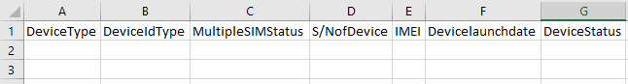

The file has the following columns:

* + **Device type**: The device can be a handheld phone, mobile phone, feature phone, smart phone, Vehicle, Portable (include PDA), Module, Dongle, WLAN router, modem, connected computer, tablet, e- Book.
  + **Device ID type**: Type can be IMEI.
  + **Multiple SIM Status**: Number of SIM slots the device supports (1-4)
  + **S/N of Device**: Device serial number
  + **IMEI**: Value of IMEI
  + **Device launch date**: Launch date or manufacturing date of the device (in the format, DDMMYYYY).
  + **Device status**: Whether the device is new or used (New/Used)
  1. Sample file with information in each column for each item is as follows:

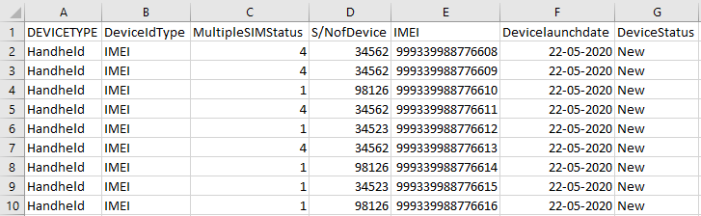

To reject the consignment, the custom can reject the consignment. While rejecting the consignment, the custom should enter the remarks

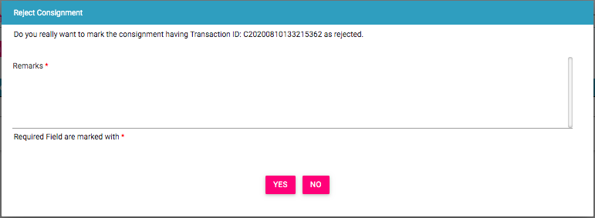

Figure 22: Reject Consignment Page

## Approve Consignments

Customs can approve the uploaded consignment. This is done when the importer has paid the tax amount to the custom.

To approve a consignment:

1. Click **Approve (****)** against the consignment to modified.

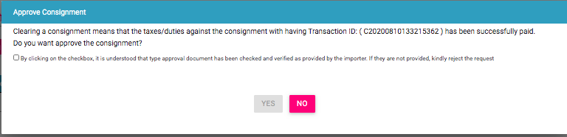

Figure 23: Consignment

1. Make the required changes
2. Click **UPDATE**.

The check box is shown in case the importer has not submitted the device document in the CEIR system before uploading the consignment. In such cases, the CEIR system expect custom to validate the document before approving the consignment

The status of the consignment changes to **Approved** and is submitted for reprocessing.

## Filter Consignments

Custom can view specific consignments after selecting the required filters. For example, custom can view consignments between specific dates by entering the start / end date.

To view specific consignments based on filters:

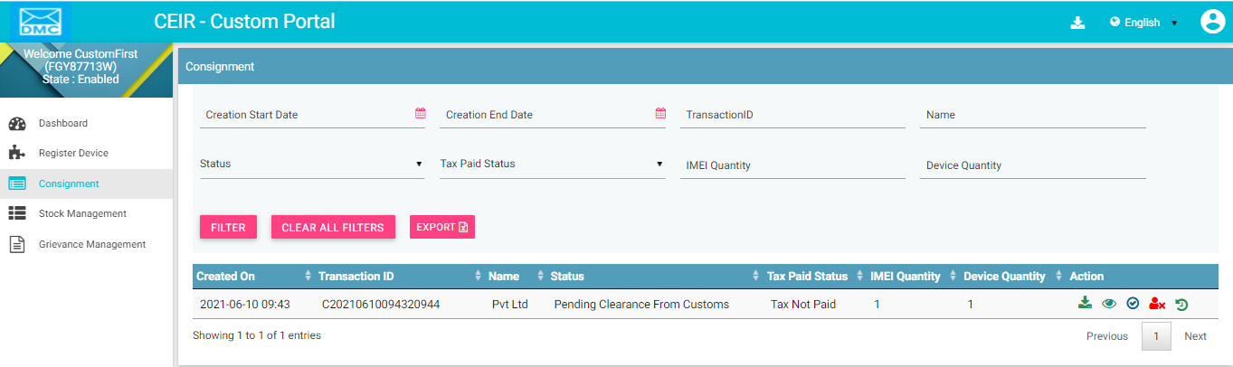

Figure 24: Consignment

1. Enter data in one or more of the listed fields:

* **Start** **Date** and **End** **Date**: This refers to the registering date of consignments in the system.
* **Transaction ID**: Each consignment is assigned a unique transaction ID. Custom can view a specific consignment by entering its transaction ID.
* **Name**: Name of the importer
* **Consignment Status**: This refers to the status of the consignment
* **Tax Paid Status**: This indicates whether tax is paid for the consignment. Custom can view selective consignments.

1. Click **FILTER**.

The consignments that match the filter values are shown in the dashboard.

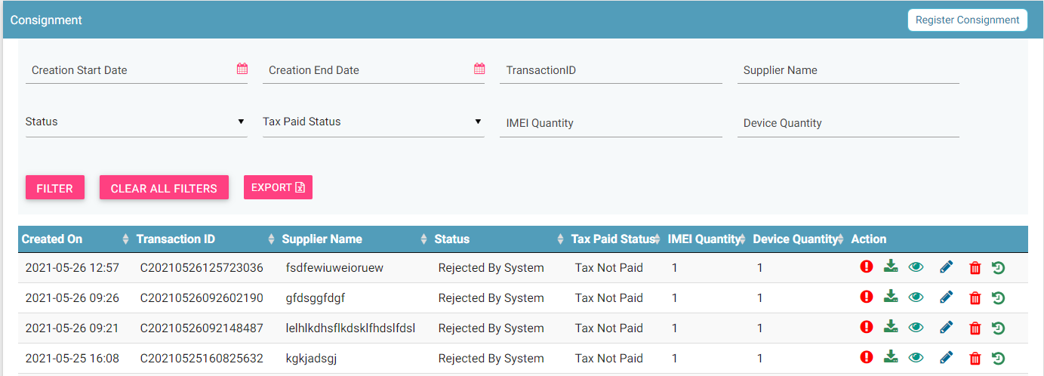

Figure 25: Filtered Consignment

The user can clear all filters using the “**Clear All Filters**” button. This will reset all the filter values applied on the page and the data table is refreshed.

## Sorting Consignments

By default, all records displayed are sorted based on modified date. User can sort the records as per his convenience by clicking the arrow button on header in the table displayed.

On first click, the records are sorted in ascending order. When user clicks the arrow buttons again, records are sorted in descending order.



Figure 26: Sort Consignment

## Export Consignments

Customs can download all the uploaded consignments in a **.csv** file. This is done using an export utility.

To export the uploaded consignments:

1. Click **Export** (seen on the top right corner of the **Consignment** page).



Figure 27: Consignment

The following page appears.

Figure 27: Open or Save Exported Consignment File

1. Click **Open with** to view the **.csv** as an Excel file.

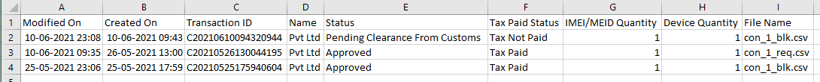

Figure 28: Exported Consignments

Filtered data can also be exported. To do this, filter specific data by defining specific filter values. Refer to *Filter Consignments* for information and then use the export feature to export the filtered data.

## Stock Management

In case the importer does not pay tax for the consignment, stock is made available for sale in the market by customs. Custom can auction the devices and can sale the stock to existing distributors/retailer in the market.

To upload stock:

1. Select **Stock Management** in the left panel.

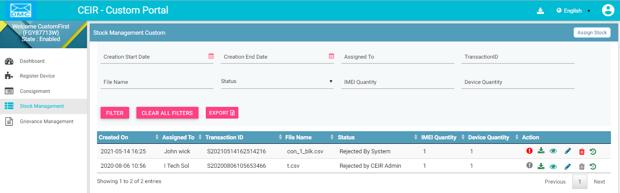

Figure 29: Stock Management Page

1. Click **Assign Stock**.

The **Assign Stock** page appears.

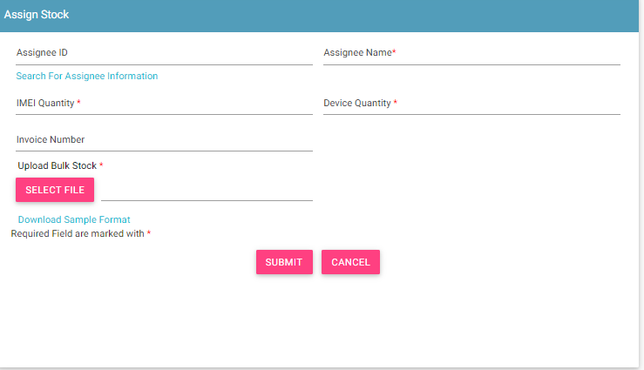

Figure 30: Assign Stock

1. Enter the following information:
   1. **Assigned ID**: Enter the assignee ID.
   2. **\*Assignee Name**: Enter the supplier name.
   3. **\*IMEI Quantity**: Enter the total quantity of IMEIs.
   4. **\*Device Quantity**: Enter the total quantity of devices.
   5. **Invoice Number**: Enter the invoice number.
   6. **\*Upload Bulk Stock**: Enter the IMEI details in a file. This is a **.csv** file with defined column names. You need to enter device information in this file. First, download the file format, if required.
   7. Click **Download Sample** **Format**.



The file has the following columns:

* + **\*Device type**: The device can be a handheld phone, mobile phone, feature phone, smart phone, Vehicle, Portable (include PDA), Module, Dongle, WLAN router, modem, connected computer, tablet, e- Book.
  + **\*Device ID type**: Type can be IMEI (International Mobile Equipment Identity)
  + **\*Multiple SIM Status**: Number of multiple SIMs the device supports (1-4)
  + **\*S/N of** **Device**: Device serial number
  + **\*IMEI**: Value of IMEI
  + **Device launch** **date**: Launch date or manufacture date of the device (in the format, DDMMYYYY).
  + **Device status**: Whether the device is new or used (New/Used)
  1. Enter the required information in each column for each device.



* 1. After you enter the device details, save the file.
  2. Click **SELECT FILE** to upload the file with all the details.

1. Click **SUBMIT**. A unique transaction ID is assigned to the uploaded stock.

The uploaded stock appears on top of the **Stock Management** page.

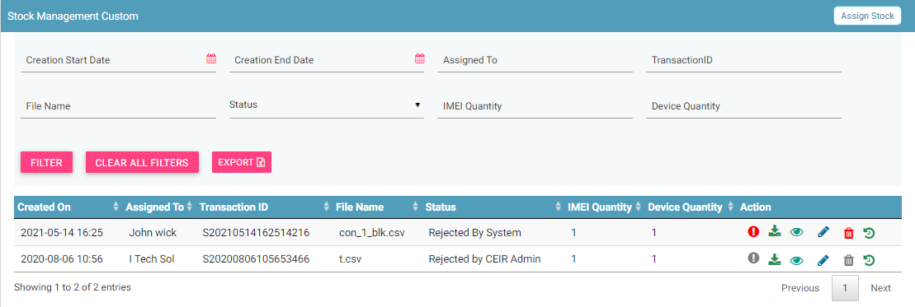

Figure 31: Stock Management

For each stock uploaded, the following columns are seen on the **Stock Management** page.

| **Column** | **Description** |
| --- | --- |
| Created On | Date of uploading the stock in the system. |
| Assigned To | This is the name of the distributor/retailer to whom the stock is assigned. |
| Transaction ID | This is an automatically generated ID that helps in identifying and tracking stock. |
| File Name | Name of the stock file. |
| Stock Status | The uploaded stock goes through different status modes.   * New: When the stock is uploaded, its status is **New**. * Processing: The stock is processed and validated. The status changes to **Processing**. * Rejected by System If the stock does not have valid information, an error file is generated. The importer can view the file and fix the errors in the consignment. * Approval Pending by CEIR Admin: The uploaded stock is available for review by the CEIR Admin. * Approved by CEIR Admin: The stock is approved by the CEIR Admin. * Rejected by CEIR Admin: The CEIR Admin reviews the details and rejects the stock if there is a problem. * Withdrawn by User: The user withdraws stock if there is any problem. * Withdrawn by CEIR Admin: The CEIR Admin can withdraw stock. |
| IMEI Quantity | This is the number of IMEIs in the stock. |
| Device Quantity | This is the number of devices in the stock. |
| Action | This displays different actions that can be performed on the stock.   * Error : This is seen when there is an error file generated because of invalid information. Click on it to view the error file. * Download A circuit board    Description automatically generated: This is used to take a dump of the stock that is uploaded to the system. * View : This is used to view the stock details. * Edit A close up of a logo    Description automatically generated: This is used to modify the stock details. * Delete : This is used to delete the uploaded stock. * History : This is used to view the transaction history of the stock. |

## Edit Stock

Custom can modify the assigned stock.

To edit stock:

1. Click **Edit (A close up of a logo

   Description automatically generated)** against the stock entry to be modified.



Figure 32: Stock Management

The **Edit Stock** page appears.

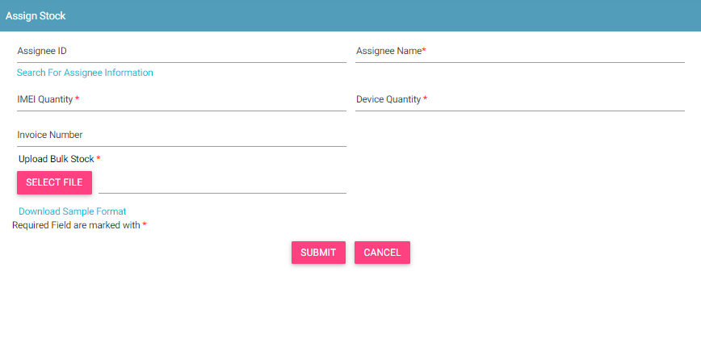

Figure 33: Edit Stock

1. Make the required changes.
2. Click **UPDATE**.

## Filter Stock

Customs can view selective stock by defining specific values in the listed fields. For example, customs can view all the stock that is in the processing status or the stock that is pending for approval by the CEIR authority.

To view specific stock:



Figure 34: Stock Management

1. Enter the required value in one or more of the listed fields:

* **Start Date and End Date**: This refers to the period of uploading stock.
* **Transaction ID**: Each stock file is assigned a unique ID. Importers can view specific stock by entering its stock transaction ID.
* **Stock Status**: This refers to the status of the stock such as New, Processing, Rejected by System, etc. Select the status of the stock to be displayed.

1. Click **FILTER**.

The stock that matches the specified values are shown in the dashboard.

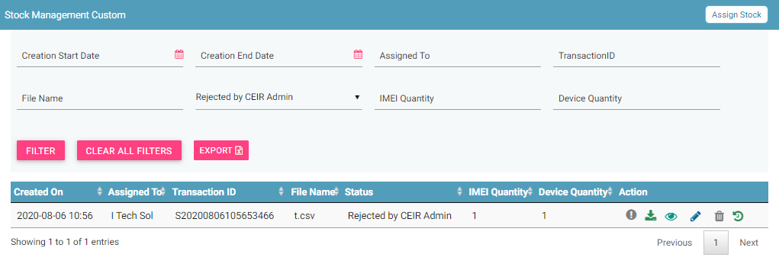

Figure 35: Stock Management

The user can clear all filters using the “**Clear All Filters**” button. This will reset all the filter values applied on the page and the data table will be refreshed.

## Sorting Stock

By default, all records displayed are sorted based on modified date. User can sort the records by clicking the arrow button on header in the table displayed.

On first click, the records are sorted in ascending order. When user clicks the arrow buttons again, records are sorted in descending order.

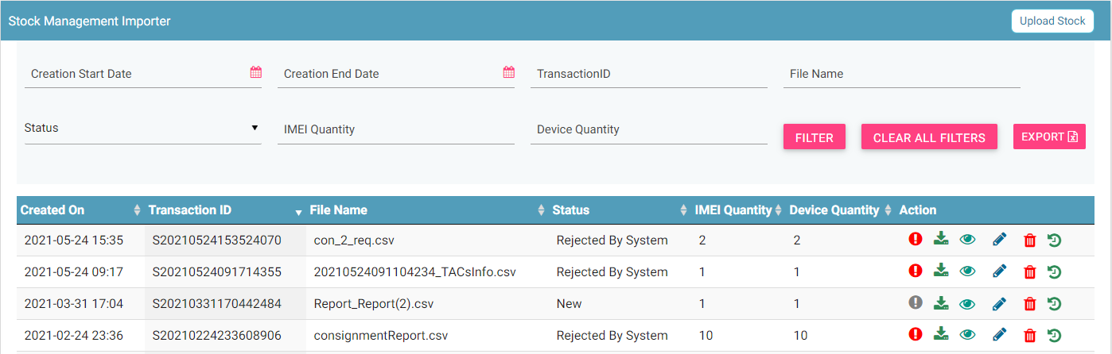

Figure 39: Stock Management

## Export Stock

Customs can download all the uploaded stock data in a **.csv** file. This is done using an export utility.

To export the uploaded stock:

1. Click **Export** (seen on the top right corner of the **Stock Management** page).

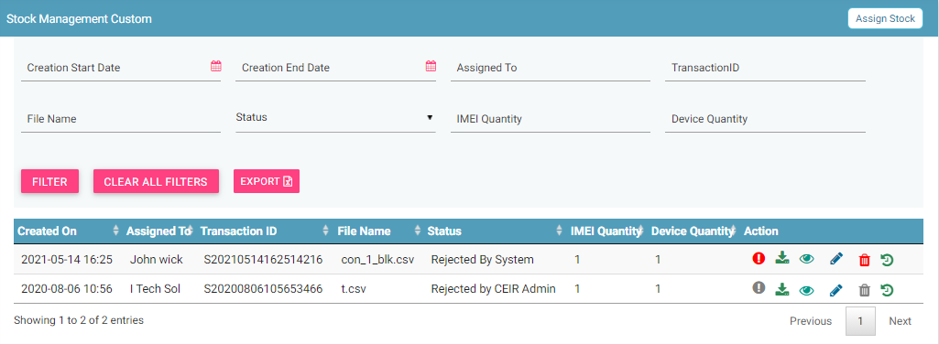

Figure 36: Stock Management

The following page appears.

Figure 37: Open or Save Exported Stock File

1. Click **Open with** to view the file. The file opens as an Excel file.



Figure 38: Exported Stock

Filtered stock can also be exported. To do this, filter stock based on specific filter values. Refer to *Filter Stock* for information and then export the filtered data.

## Grievance Management

Customs can register complaints or grievances when there is a problem in the portal. For example, there could be situations when the registration feature is not working or there could be a problem in consignment approval.

When a custom raises a grievance, the grievance goes through the following stages:

1. A notification is sent to the CEIR Admin. The notification appears on the CEIR Admin portal. A mail is also sent to the registered mail of the CEIR Admin.
2. The CEIR Admin responds to the grievance. A response notification is sent to on the custom portal, and the custom’s registered mail ID.
3. Steps 1 to 2 are repeated until the grievance is closed. The CEIR Admin closes the grievance.

There are situations when the grievance is automatically closed. A grievance is automatically closed when the status of the grievance changes to **Pending with User**, but there is no response from the importer for a specified period.

To raise a grievance

1. Select **Grievance Management** in the left panel.

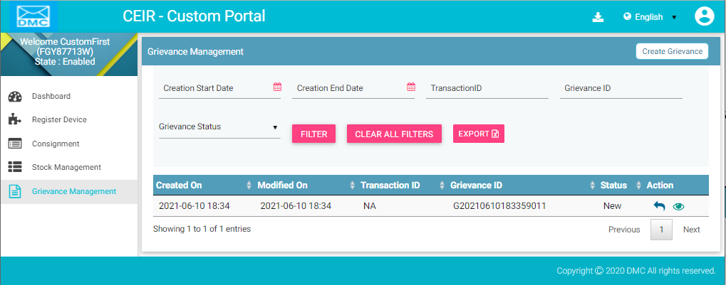

Figure 39: Grievance Page

1. The **Grievance Management** page appears. Click **Create Grievance**.

The **Create Grievance** page appears.

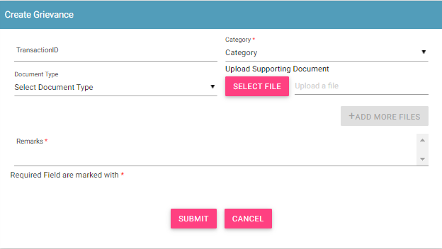

Figure 40: Create Grievance

1. Enter the following information:
   1. **Transaction ID**: Enter the transaction ID of the consignment if the grievance is related to a consignment or the transaction ID of the stock if the grievance is related to stock.
   2. **\*Category**: Select the category of the grievance. The options are:

* Consignment Related: Problem with registering consignment etc.
* Register Device Related: Problem with register device feature
* Stock Related: Problem with uploading stock etc.
* Other: Problem with any other aspect of the application
* Registration Related: Problem with registering information in the application.
  1. **\*Remarks:** Enter information about the grievance raised. This helps the Admin to understand the problem in detail.
  2. **Document Type:** Select the type of identification or another document that is to be uploaded. The options are:
* Passport
* Visa
* NID (National ID)
* Photo
* Other
  1. **Upload Supporting Document:** Click **Select File** to upload the document selected in **Document Type**.
  2. To upload more documents,click **+Add More Files.**

This adds two more fields: **Document Type** and **Select File**.

1. Click **SUBMIT**.

A grievance ID is generated and assigned to the registered grievance. The registered grievance appears on top of the dashboard.

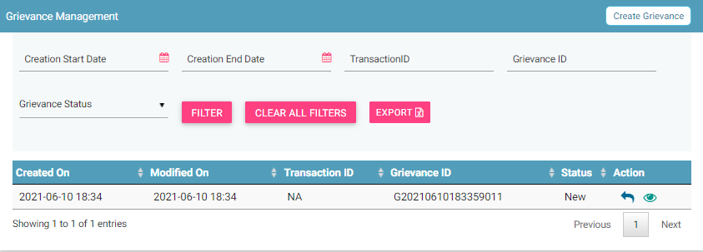

Figure 41: Grievance Management

For each grievance added, the following information is displayed on the page.

| **Column** | **Description** |
| --- | --- |
| Created On | Date of raising a grievance. |
| Modified On | The date when the grievance was modified. |
| Transaction ID | The transaction ID of stock or consignment for which a grievance was raised. |
| Grievance ID | This is the ID that is automatically assigned to the grievance. |
| Grievance Status | The uploaded grievance goes through different status modes.   * New: When a grievance is raised. * Pending with CEIR Authority: When a response is awaited from the CEIR Admin. * Pending with User: When a response is awaited from the importer. * Closed: When the CEIR Admin closes the grievance. |
| Action | This displays different actions that can be performed on a grievance.   * Reply : This is used to respond to the grievance. The response is given by the CEIR Admin or importer. The exchange of responses is done until the grievance is closed. * View A close up of a logo    Description automatically generated: This is used to view the grievance response history. The importer can see all the responses exchanged for any grievance. |

## Filter Grievances

The customs can view selective grievances depending on specific filter values. For example, the customs can view only those grievances that are pending with the CEIR Admin. Similarly, one can view only those grievances that are closed.

To filter grievances:



Figure 42: Filter Grievances

1. Specify the required value in one or more of the fields listed:

* **Start Date** and **End Date**: Period of raising grievances.
* **Transaction ID**: This is the transaction ID of the stock or consignment.
* **Grievance ID**: This is the ID assigned to the grievance.
* **Grievance Status**: The status can be:
  + New
  + Pending with CEIR Admin
  + Pending with User
  + Closed

1. Click **Filter**.

The filtered grievances are shown on the page.



Figure 43: Filtered Grievances

The user can clear all filters using the “**Clear All Filters**” button. This will reset all the filter values applied on the page and the data table will be refreshed.

## Sorting Grievance

By default, all records displayed are sorted based on modified date. User can sort the records by clicking the arrow button on header in the table displayed.

On first click, the records are sorted in ascending order. When user clicks the arrow buttons again, records are sorted in descending order.



Figure 39: Grievance Management

## Export Grievances

All the uploaded grievances can be downloaded in a **.csv** file. This is done using an export utility.

To export the grievances:

1. Click **Export** (seen on the top right corner of the **Grievance Management** page).



Figure 44: Grievance Management

The following page appears.

Figure 45: Open or Save Exported Grievance File

1. Click **Open with** to view the file.

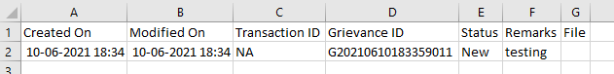

Figure 46: Exported Grievances

Instead of exporting all the grievances, custom can export filtered grievances. First, filter the grievance data based on specific filters (refer to *Filter Grievances*) and then export the filtered grievances using the export utility.

## Registering Devices

The custom officials use the CEIR application to register devices that are brought into Cambodia by foreigners/local Cambodian users. The registered device is used to build a device database. The end user has to pay taxes on the devices as per the applicable CEIR policy

### Registering Imported Devices

To register a device:

1. Select **Register Device** in the left panel of the home page.

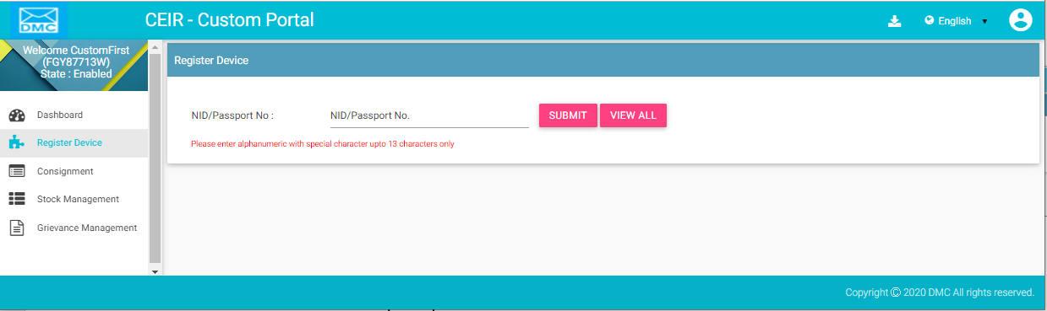

Figure 47: Register Device

1. Enter the NID passport number.
2. Click **Submit**.

If there are any existing registered devices that are associated with the passport number entered, the following page appears.

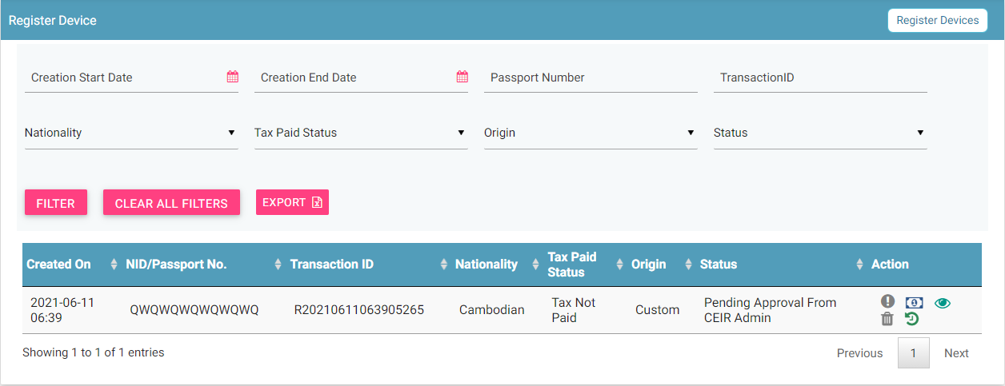

Figure 48: Register Device

1. Click on **Register Device** on the top right of the form. Following form appears.

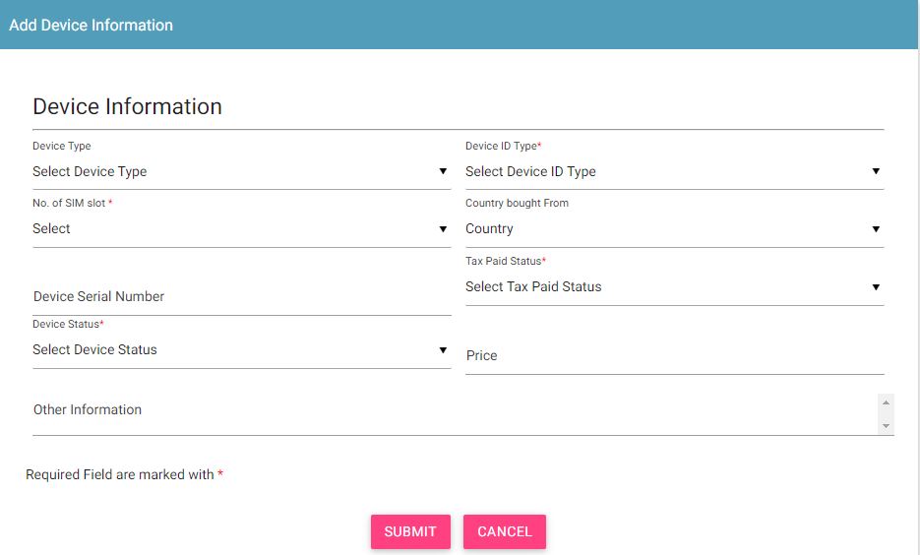

1. Enter the following information:

* **Device Type**: Select the type of device:
  + Mobile Phone
  + Feature Phone
* \***Device ID Type**: Select the type of ID of the device that would be entered for identification:
  + IMEI
* \***No. of SIM slot**: Number of multiple SIMs the device supports (1-4)
* **Country bought from**: Select the country from where the device was bought.
* **Device Serial Number**: Enter the serial number of the device.
* \***Tax Paid Status**: Select the tax paid status
* **Price**: Price of the device
* \***Device Status**: Select the status of the device:
  + New
  + Old
* \***IMEI**: Enter the ID value(s). A maximum of 4 ID values can be entered.
* Click **Submit**.

A unique transaction ID is generated, and the request is processed internally. The registration request appears on top of the page.

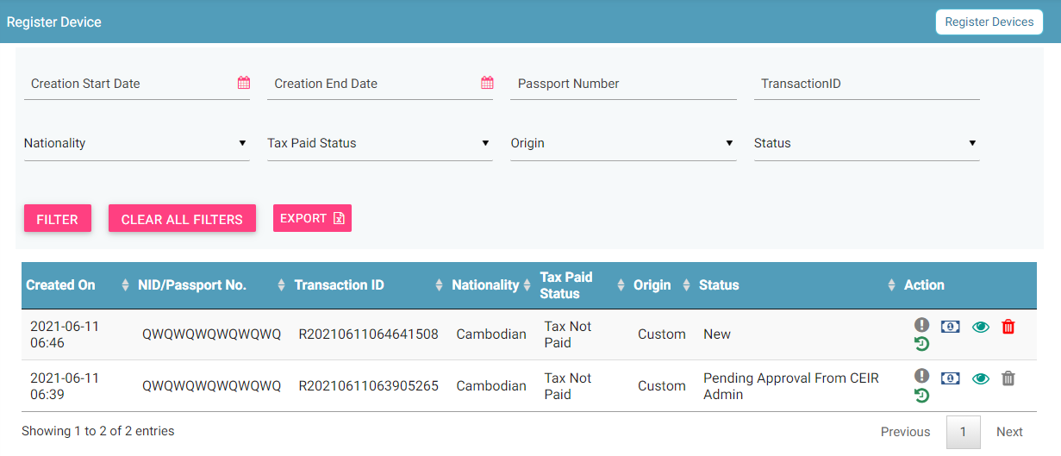

Figure 50: Register Device

If the passport number/NID is not found in the system and there is no device registered with the passport, the following page appears.

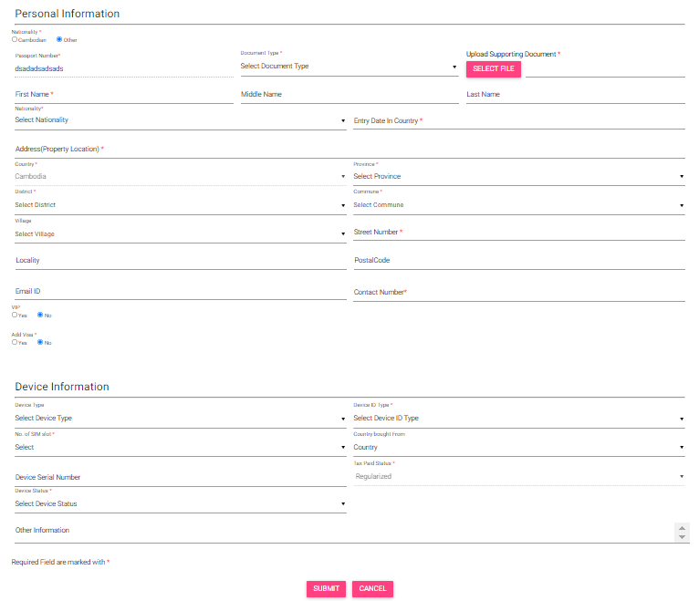

Figure 51: Register Device

Enter information about the person who is visiting Cambodia.

1. Enter the following information:

**Personal Information:** Enter the personal details of the person.

* \***Passport Number**: NID/Passport number entered by the user at the time of opening the register device form will be pre-filled by the system here.
* \***Upload Supporting Document**: Select the type of document to be uploaded for identification.
  + Passport
* \***First Name**
* **Middle Name**
* **Last Name**
* \***Nationality**
* \***Entry Date in Country**: Select the date of entry in Cambodia.
* \***Address (Property Location)**
* \***Street Number**
* **Village**
* **Locality**
* \***District**
* \***Commune**
* **Postal Code**
* \***Country**
* \***Province**
* **Email**
* \***Contact Number**
* **VIP**: Select Yes or No depending on the status of the person.
  + Department Name: Enter the department of the person. This is applicable only if the person is a VIP.
  + Department ID: Enter the department ID of the person. This is applicable only if the person is a VIP.
  + Upload Department ID Image: Click File to upload an image of the department identification of the person. This is applicable only if the person is a VIP.
* **Add Visa**: Select Yes or No depending on whether the person has a visa.
  + Visa Type: Select the type of visa. This is applicable only if the person has a visa.
  + Visa Number: Enter the visa number. This is applicable only if the person has a visa.
  + Visa Expiry Date: Select the expiry date of the visa. This is applicable only if the person has a visa.
  + Upload Visa Image: Click File to upload the visa image. This is applicable only if the person has a visa.

**Device Information**

* **Device Type**: Enter details of the device.
* \***Device ID Type**: Select the type of ID to be entered for the device:
  + IMEI
* \***No. of SIM slot**: Number of multiple SIMs the device supports (1-4)
* **Country Bought from:** Select the country
* **Device Serial Number:** Enter the serial number
* \***Tax Paid Status:** Select the tax paid status
* **Price:** Enter the price
* \***Device Status:** Select the device status
* \***IMEI**: Enter the value of the IMEIs of the device.
* Click **Submit**.

A unique transaction ID is generated, and the request is processed internally. The request can be seen on top of the page.

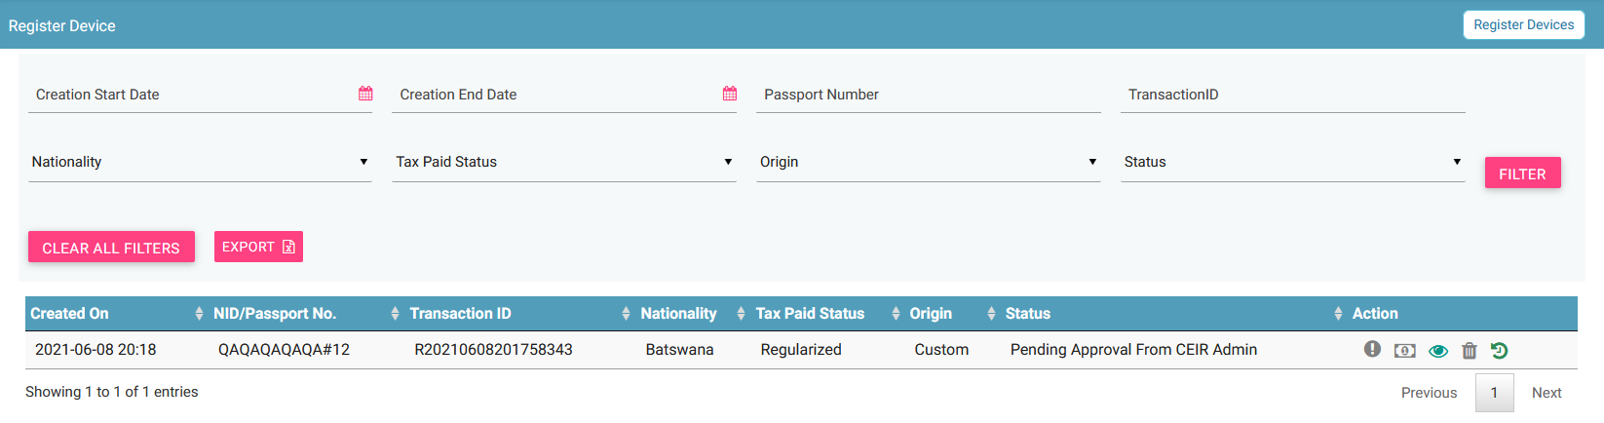

Figure 52: Register Device

For each request, the following information is displayed:

| **Column** | **Description** |
| --- | --- |
| Date | Date of registering the request. |
| Passport No/NID | Passport number/National ID |
| Transaction ID | Transaction ID assigned to the request. |
| Nationality | Nationality of the person entering Cambodia. |
| Tax Paid Status | Indicates whether tax has been paid for the device. |
| Origin | This indicates who has raised the request. The value can be   * End user * Immigration * Custom |
| Status | * The request goes through the following status modes:   + New: When a request is raised, the status is New.   + Processing: The request is verified internally.   + Rejected by System: If the request has an error, an error file is generated. The error file can be downloaded. The error could be in the file format, size, policy violation or request specifications.   + Pending Approval from CEIR Admin: If the request is successfully verified by the system, the request is shared with the CEIR Admin for review.   + Rejected by CEIR Admin: The CEIR Admin reviews the details and rejects the request if there is a problem. The official can view the error file and fix the errors in the request.   + Approved by CEIR Admin: When the CEIR Admin approves the request, the status changes to Approved by CEIR Admin. |
| Action | This displays different actions that can be performed on the request.   * Error : An error file is generated if there is any problem in the request(s) submitted. Click to download the error file. Refer to *Figure 18* for a sample error file. * Pay Tax : This is used to pay Tax of the device. Once the tax is paid, then tax paid status of device is changed to tax paid. * View : This is used to view the request. Click on it view the request details. * Delete : This is used to delete the request. This is allowed only when the request status is New or Rejected by System. Click on it to delete the request. * History : This is used to view the history of the transaction. |

## Filtering Register Device Requests

Custom officials can view selective device requests after specifying the required filters. For example, they can view requests that are pending approval from the CEIR Admin.

To filter device requests:

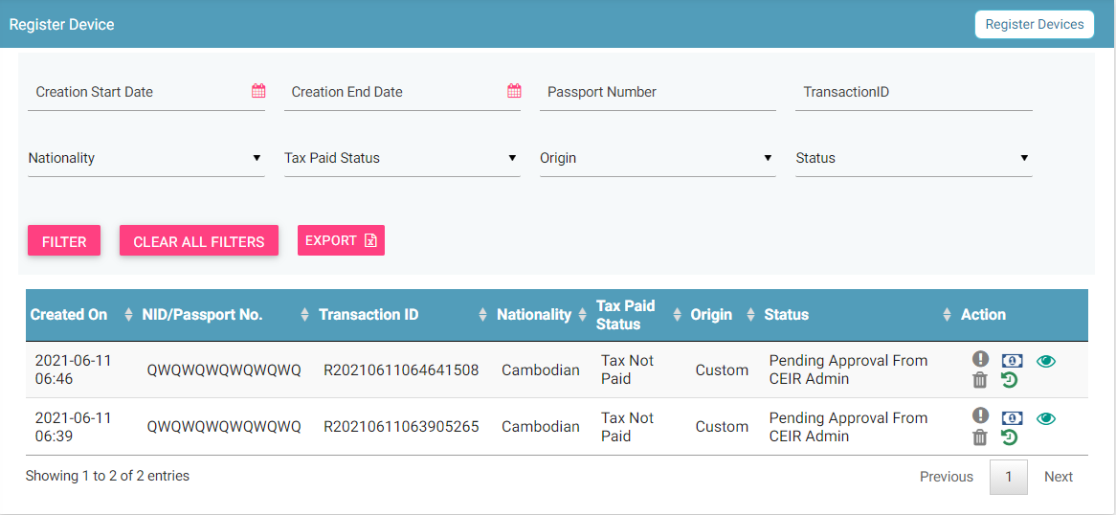

Figure 53: Filter Device Requests

1. Enter data in one or more of the listed fields:

* **Start** **Date** and **End** **Date**: This refers to the period of registering devices.
* **Transaction ID**: Each request is assigned a unique transaction ID.
* **Status:** Status of the request.
* **Tax Paid Status**: Whether tax has been paid for the device.

1. Click **FILTER**.

The requests that match the filter values are shown in the dashboard.

The user can clear all filters using the “**Clear All Filters**” button. This will reset all the filter values applied on the page and the data table will be refreshed.

## Sorting Register Device Requests

By default, all records displayed are sorted based on modified date. User can sort the records by clicking the arrow button on header in the table displayed.

On first click, the records are sorted in ascending order. When user clicks the arrow buttons again, records are sorted in descending order.

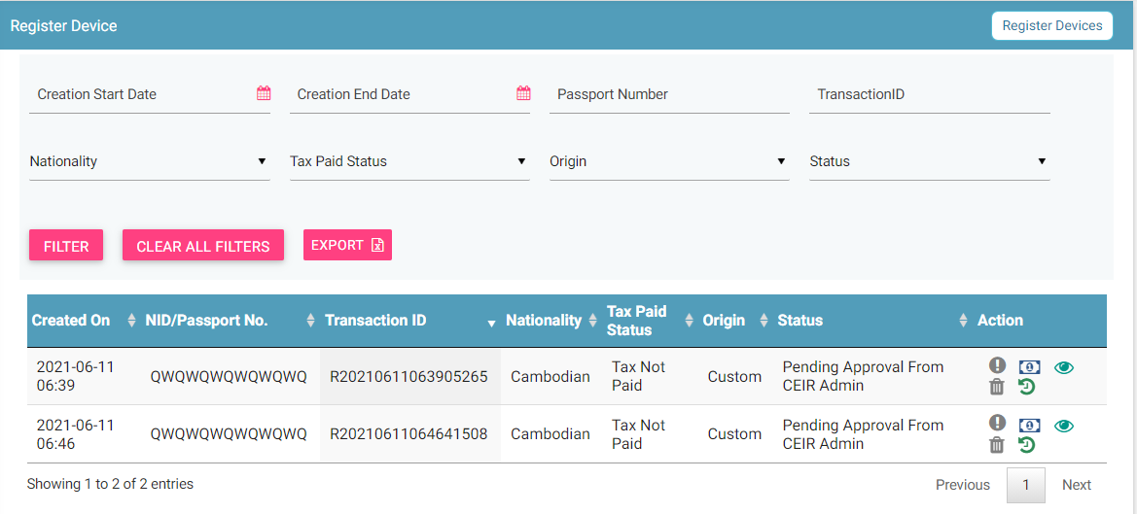

## Exporting Register Device Requests

Custom officials can download all the uploaded requests in a **.csv** file. This is done using an export utility.

To export the uploaded requests:

1. On the **Register Device** page, click **Export**.



Figure 54: Register Device

The following page appears.

Figure 55: Open or Save Register Device File

1. Click **Open with** to view the **.csv** as an Excel file.



Figure 56: Exported Register Device File

Filtered data can also be exported. To do this, filter specific data by defining filter values. Refer to *Filter Register Device Requests* for information and then use the export feature to export the filtered data.